FastUMI Hardware Startup Procedure_en

### Startup Prerequisites

The FastUMI Hardware startup procedure involves multiple components, including hardware connections, the Vive tracking system, SteamVR, and the ROS SDK. All configurations and startup steps must be performed strictly in the order specified in this document.

Before startup, please ensure the following:

* The device interface types are correctly selected and all USB connections are secure and stable.
* The base stations are properly powered on and configured with correct channel settings.
* The operating system environment is Ubuntu 20.04.
* SteamVR configuration files are modified as required and SteamVR is launched in compatibility mode.
* In multi-device scenarios, sufficient USB bandwidth expansion has been completed in advance.

If any startup abnormality occurs, terminate all related processes and restart the system following the complete startup procedure. Avoid skipping steps or repeatedly hot-plugging devices, as this may lead to hardware recognition failures or system instability.

# Hardware Setup and Connection

## 1.1 Device Placement Reference

The overall device layout for the test environment is illustrated below and is provided for reference only. The actual setup shall be determined according to on-site conditions.

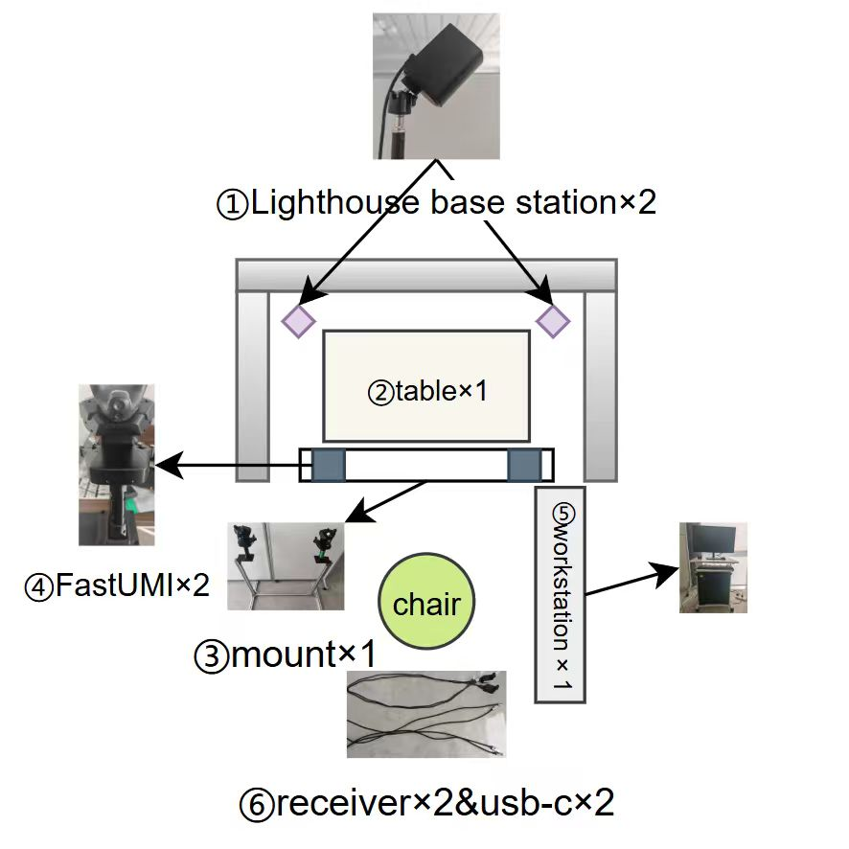

## 1.2 Connection Method Description

Please strictly follow the instructions in the table below to complete the connection between the devices and the workstation:

1. Place the FastUMI unit on the dedicated FastUMI mounting fixture. The connections between the receiver and the workstation via USB-C 3.2 Gen 2 shall be established as specified in the table below.

|  |  |
| --- | --- |
| Receiver 1 | USB 2.0 or above (USB 2.0 is sufficient) |
| Receiver 2 | USB 2.0 or above (USB 2.0 is sufficient) |
| USB-C3.2Gen2-1 | usb3.0 |
| USB-C3.2Gen2-2 | usb3.0 |

1. Connect the FastUMI data transmission port to the USB-C 3.2 Gen 2 Type-C port. Insert the connector gently and carefully verify that the connection is secure and fully seated.

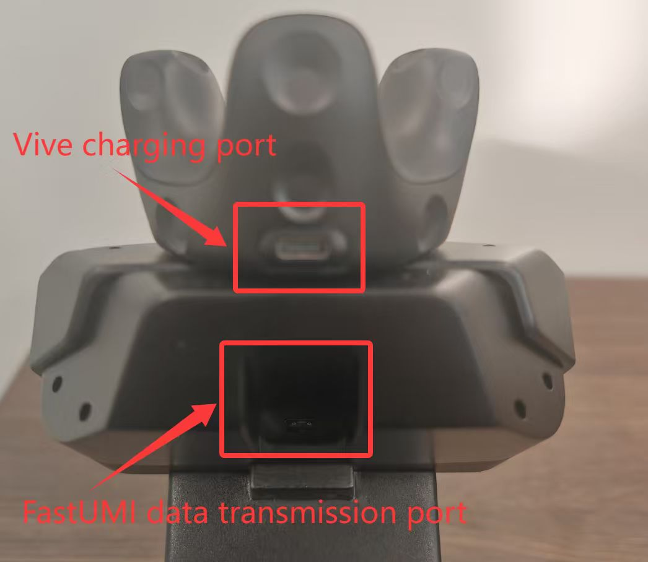

# 2. Vive Initialization Procedure

## 2.1 Base Station Installation

Mount the Vive base stations onto the top of the tripods. Adjust the orientation and spacing of the base stations to ensure that the Vive system can establish simultaneous tracking connections with both base stations.

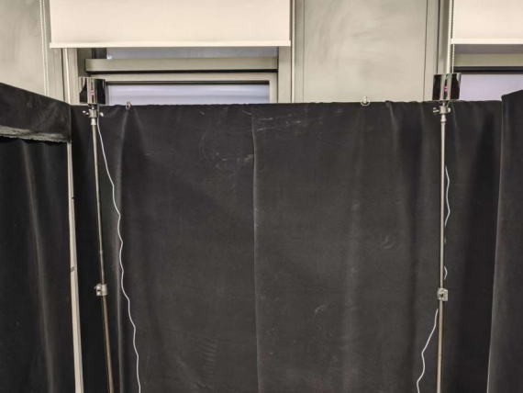

Connect the power cable to each base station, then plug the cables into power outlets to switch on the base stations.

## 2.2 SteamVR Installation

#### **Steam Installation**

Open a Terminal window and execute the following command to install the Steam platform:

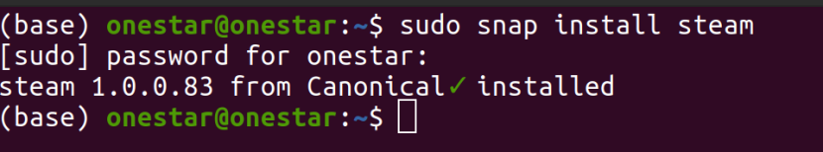

#### **SteamVR Installation**

Log in to the Steam platform, search for SteamVR, and install the application.

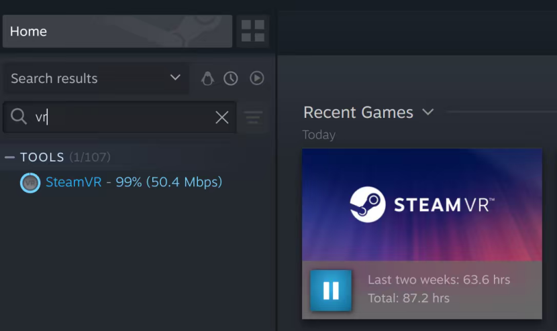

#### **SteamVR Configuration Modification**

**a. Modify default.vrsettings**

Click the gear-shaped Settings icon in SteamVR, then locate and open the local installation directory of SteamVR.

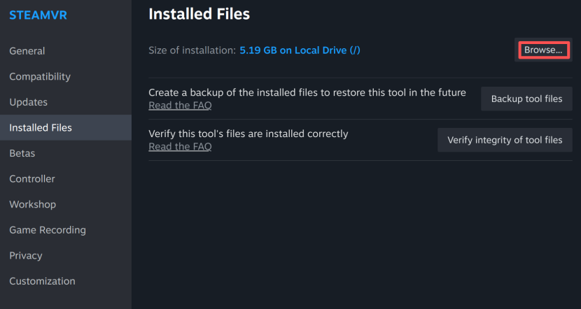

Continue to the /resources/settings directory, open the default.vrsettings file, and set the parameter requireHmd to false.

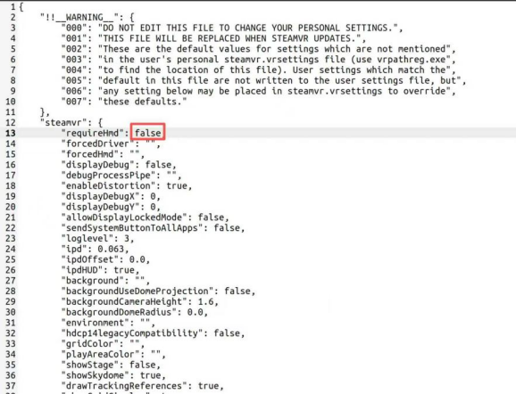

**b. Launch SteamVR in Compatibility Mode**

In the Compatibility settings, enable Steam Linux Runtime (version 3.0 is recommended), then launch SteamVR.

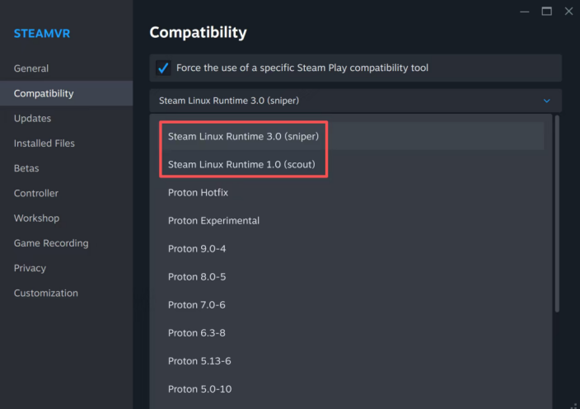

## 2.3 Vive Pairing

#### **Receiver Connection**

Connect the receiver to the host workstation using a **USB 2.0 or higher–compliant port**.

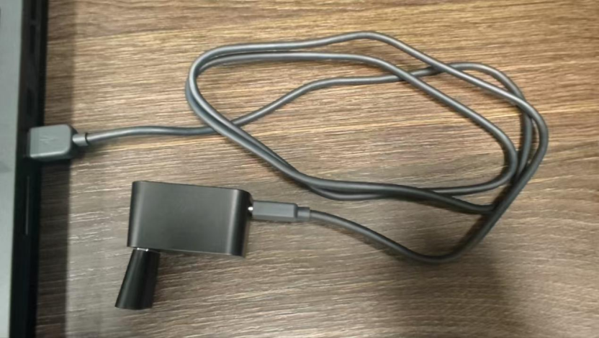

#### **Vive Pairing**

Press and hold the Vive power button for approximately 3 seconds until the indicator LED enters a blue flashing state.

In the SteamVR menu, navigate to Device → Pair Controller, then select HTC Vive Tracker to initiate the pairing process.

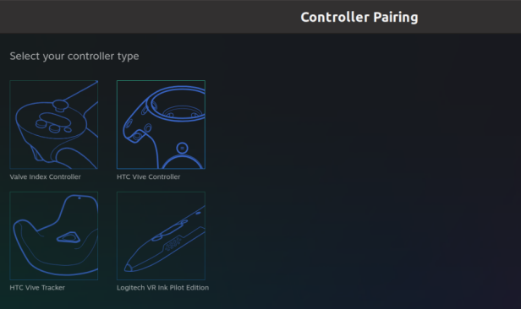

After the pairing process is completed, the connected devices can be viewed in SteamVR.

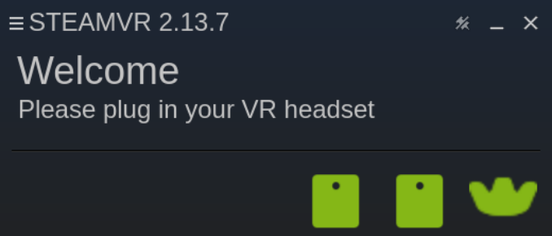

#### **Base Station Configuration**

When connecting the Vive base stations, please note that the base stations are set to **Channel 1 by default** during initial connection.

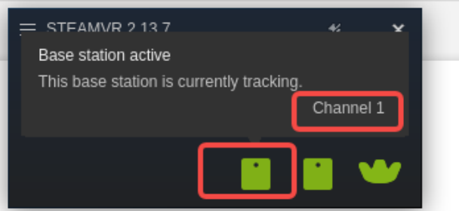

When multiple base stations are used simultaneously, each base station must be configured with a different channel.

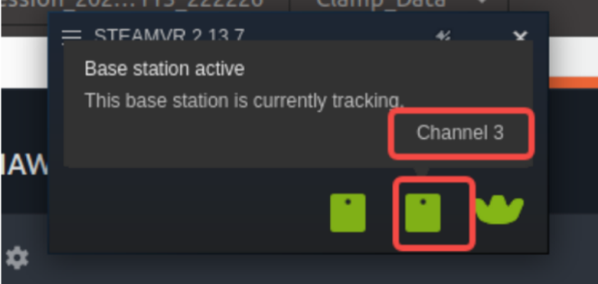

To configure different base station channels, press the recessed pinhole button on the rear of the base station. Each press increments the channel number by one. The channel value cycles within the range of 1 to 16.

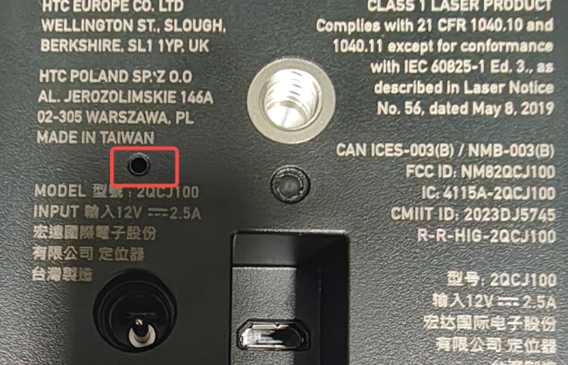

# 3. SDK Installation and Configuration

## 3.1 Prerequisites

**ROS Environment Setup**

## 3.2 SDK Installation

## 3.3 FastUMI Connection

**Note:** Ensure that FastUMI is properly connected to the host computer before proceeding.

## 3.4 USB Bandwidth Expansion (Optional, Required for Multi-Device Setups)

## 3.5 Troubleshooting

**Issue:** SDK fails to launch using roslaunch.

**Resolution:**

Terminate all related processes and restart the SDK following the standard startup procedure.